Telemetry User Guide

Map with elevation
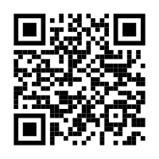

Telemetry Code Design Docs
